**Name: Roma Shirodkar**

**Div: D15B / 54**

**Aim:** To setup firebase with flutter.

**Steps:**

1. Go to Firebase official website

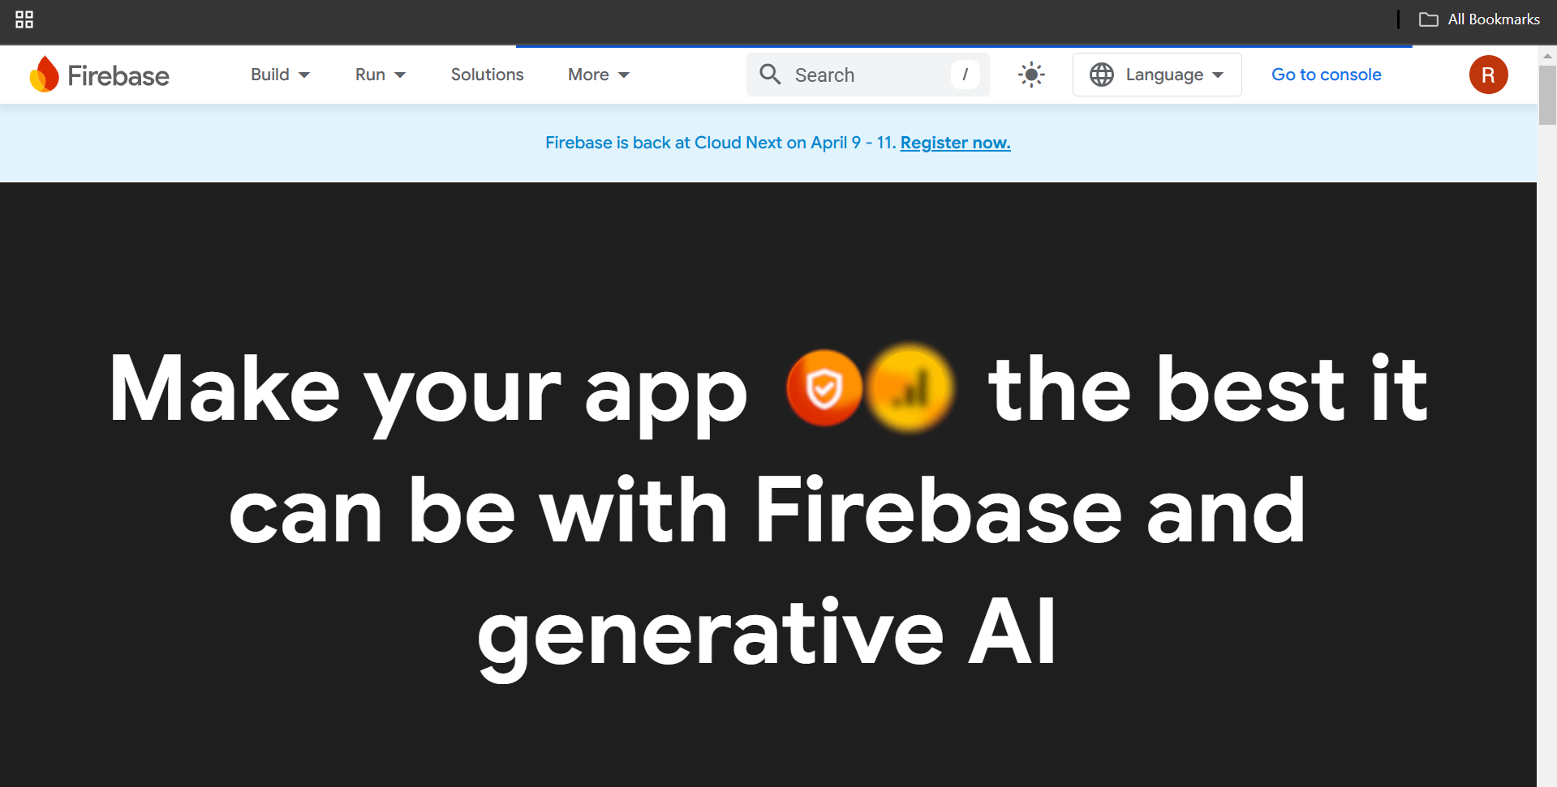

1. Scroll down and we’ll see a “Get started” button. Click on it. We can see the following, choose “Get started with a firebase project”

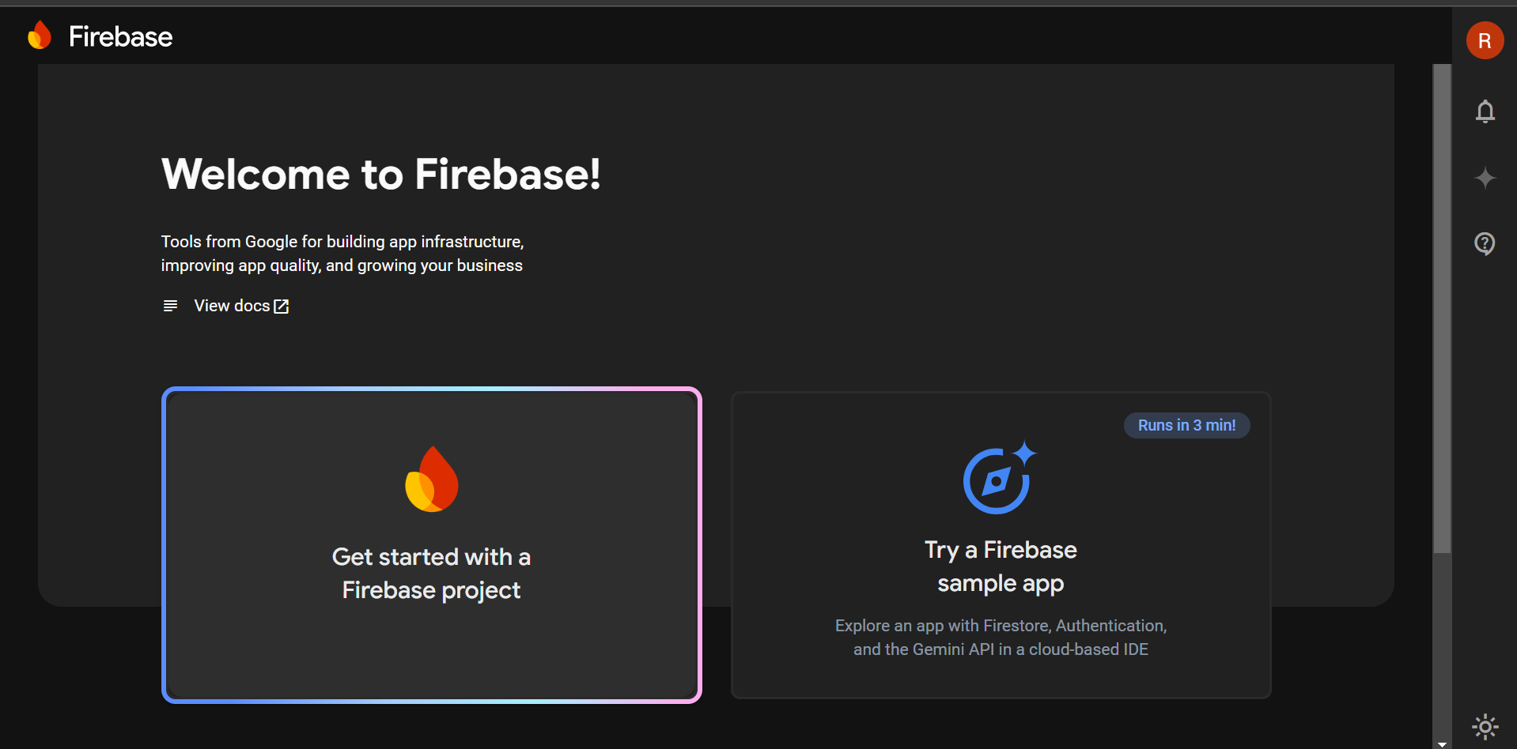

1. Name your project. I have named “Mad-lab”

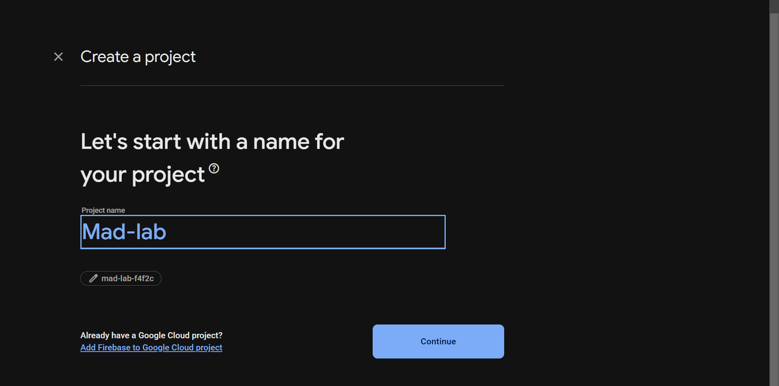

1. Select appropriate settings. Below is one example of it.

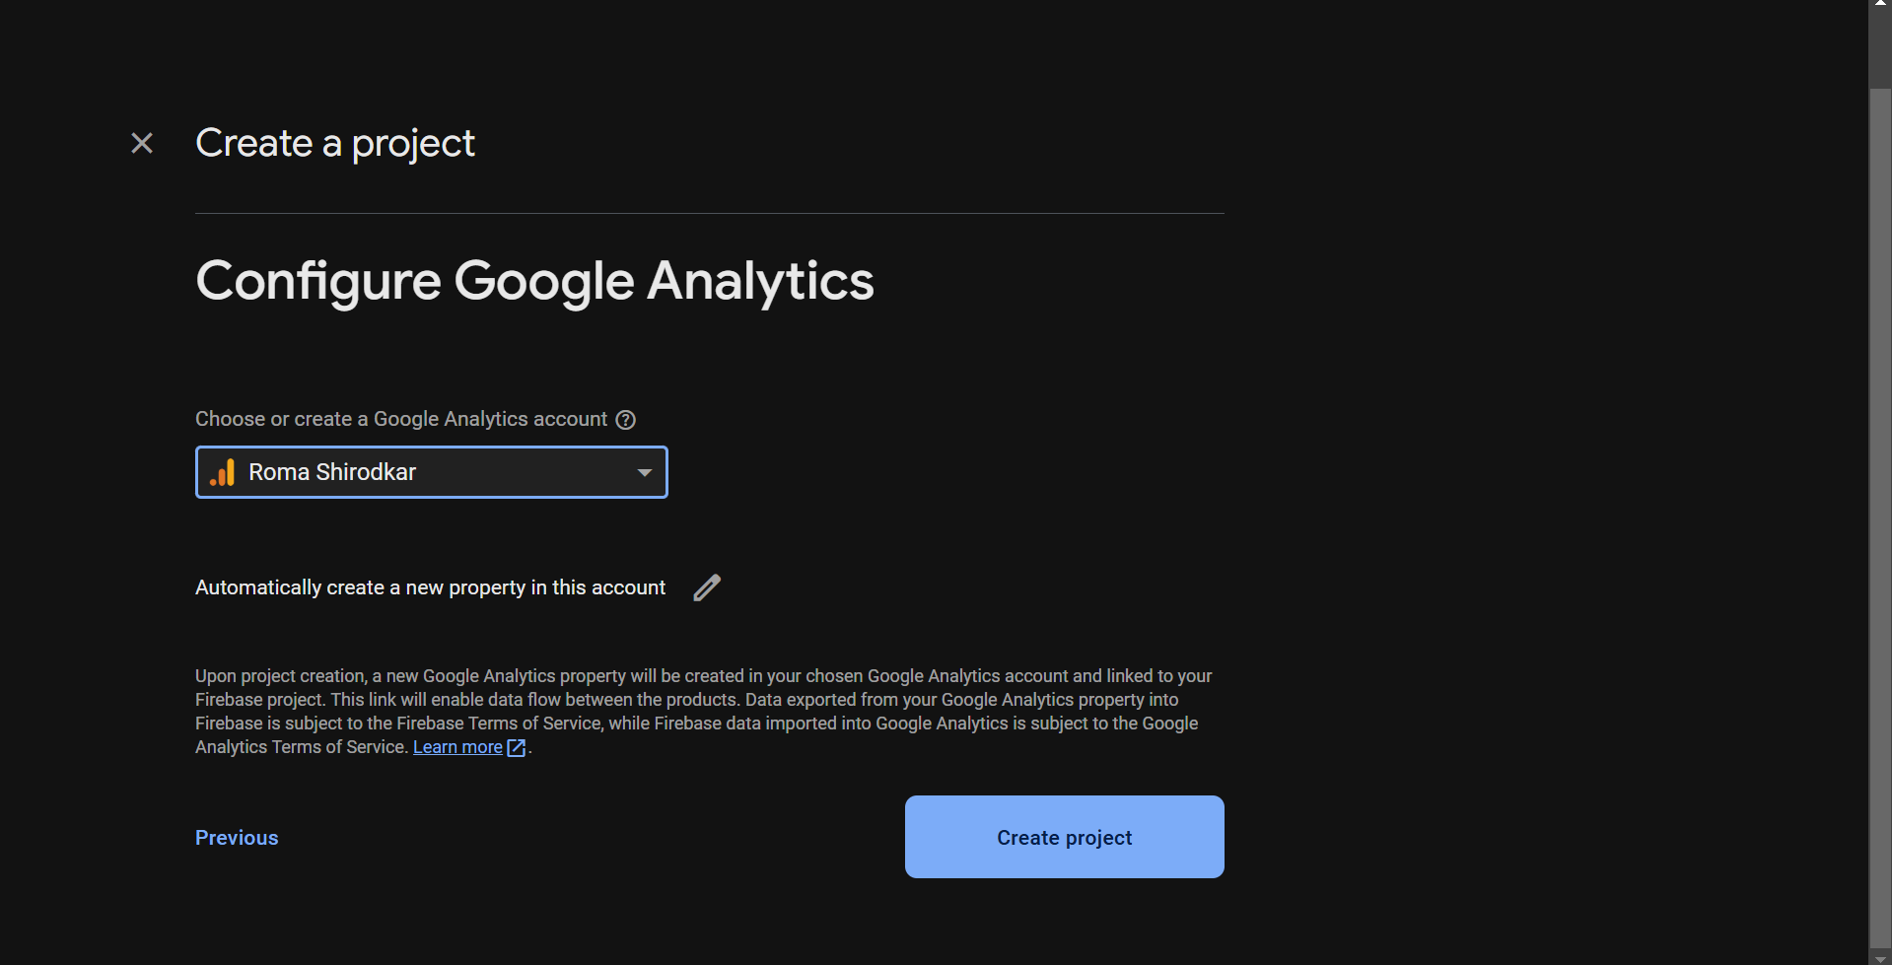

1. After you have completed all the steps you will see the following.

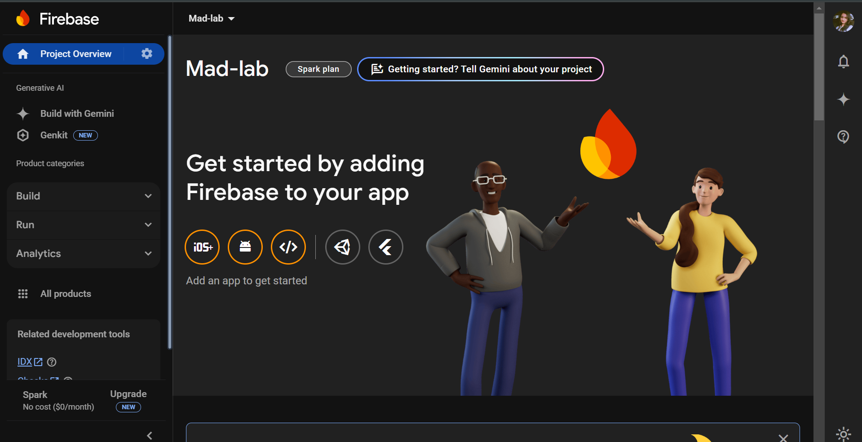

1. After these steps we need to verify-

* google-services.json (for Android) is in android/app/
* GoogleService-Info.plist (for iOS) is in ios/Runner/
* Ensure the firebase_core package is initialized correctly.

1. Initialize Firebase in main.dart:

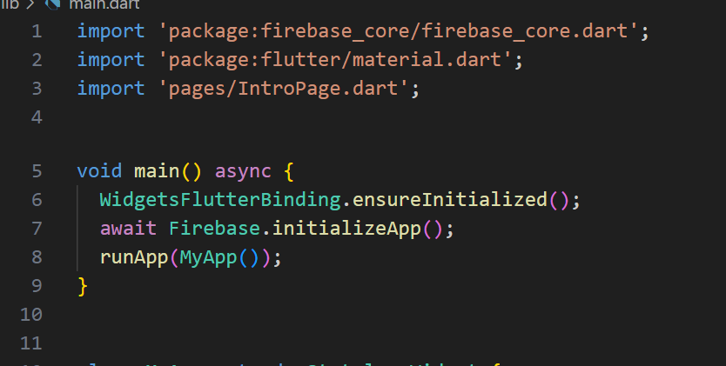

1. Run the following commands to add the packages

flutter pub add firebase_auth

flutter pub add cloud_firestore

flutter pub add firebase_storage

flutter pub add firebase_messaging

1. Android Configuration:

Ensure google-services.json is in android/app/.

1. Test Firebase Integration:

flutter clean

flutter pub get

flutter run

After that you will see the following new folders and files

